Exam 2 Review

- The feasible region determined by a system of constraints is given. Find the maximum and minimum of the objective function.

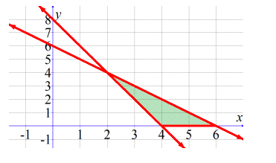
$$C=-2x+5y$$

Maximum: Minimum:

- The feasible region determined by a system of constraints is given. Find the maximum and minimum of the objective function.

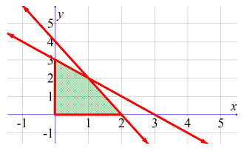
$$C=5x-3y$$

Maximum: Minimum:

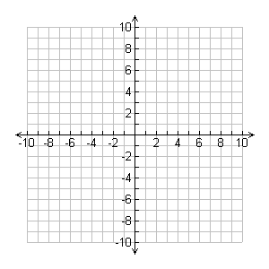
- Given the following inequalities:
$2x+3y≤12$
$$2x+y≤8$$
$$x≥0$$
$$y≥0$$

  - Graph the constraints
  - Find the vertices of the feasibility region

  - Test each vertex in the objective function $C=4x+3y$to find the minimum and maximum values

- Given the following inequalities:
$$x+y≤3$$
$$x+2y≤4$$
$$x≥0$$
$$y≥0$$

  - Graph the constraints
  - Find the vertices of the feasibility region

  - Test each vertex in the objective function $C=2x-y$to find the minimum and maximum values

- A shoe manufacturer makes outdoor and indoor soccer shoes. There is a two-step manufacturing process for both kinds of shoes, cutting and sewing. Each pair of outdoor shoes requires 2 hours of cutting and 1 hour or sewing. Indoor shoes require 1 hour of cutting and 3 hours of sewing. The company has only 40 hours of labor available for cutting and 60 hours available for sewing. Outdoor shoes make a profit of $20 per pair and indoor shoes make a profit of $15 per pair. How many pairs of each shoe should be made to maximize profit? What is the maximum profit?
- Define the variables

- Write the constraints

- Write the objective function

- The Acme Class Ring Company designs and sells two types of rings: the VIP and the SST. They can produce up to 24 rings each day using up to 60 total man-hours of labor. It takes 3 man-hours to make one VIP ring, versus 2 man-hours to make one SST ring. How many of each type of ring should be made daily to maximize the company's profit, if the profit on a VIP ring is $30 and on an SST ring is $40?
  - Define the variables

  - Write the constraints

  - Write the objective function

- You invest $5,000 in an account that pays 2.8% interest.
  - How much will you have in the account in 5 years if interest is compounded monthly?

  - How much interest will you earn?

  - How much will you have in the account in 5 years if interest is compounded continuously?

  - How much interest will you earn?

  - Which account earned more interest? How much more?

- You invest $4,000 in an account that pays 3.25% interest.
  - How much will you have in the account in 10 years if interest is compounded monthly?

  - How much interest will you earn?

  - How much will you have in the account in 10 years if interest is compounded continuously?

  - How much interest will you earn?

  - Which account earned more interest? How much more?

- You invest $6,000 in an account that pays 3.9% annual interest compounded monthly. When will you have double the amount of money in the account?

- You invest $2,000 in an account that pays 2.8% annual interest compounded quarterly. When will you have triple the amount of money in the account?

- How much money must you deposit today in an account that earns 1.89% interest compounded continuously if you want to have $1000 in 2 years?

- How much money must you deposit today in an account that earns 2.6% interest compounded continuously if you want to have $2000 in 4 years?

- What interest rate do you need if you want to turn $2000 into $5000 in 5 years with interest compounded continuously?

- What interest rate do you need if you want to double your initial investment of $750 in 3 years if interest is compounded continuously?

- Assembly-line operations tend to have a high turnover of employees, forcing the companies involved to spend much time and effort in training new workers. It has been found that a worker who is new to the operation of a certain task on the assembly line will produce $P(t)$ items on day $t$, where $P\left(t\right)=-25e^{-0.3t}+25$.
- Graph this equation by identifying and labeling the horizontal asymptote, t-intercept, and y-intercept.

- How many items will be produced on the eighth day?

- Interpret the meaning of the y-intercept.

- Interpret the meaning of the horizontal asymptote.

- On what day will the worker be able to produce 15 items?

- The number of words per minute that an average person can type is given by $W\left(t\right)=-30e^{-0.5t}+60$, where $t$ is time in months after the beginning of a typing class.
- Graph this equation by identifying and labeling the horizontal asymptote, t-intercept, and y-intercept.

- How many words per minute can the average person type after 4 months?

- Interpret the meaning of the y-intercept.

- Interpret the meaning of the horizontal asymptote.

- When will the average person be able to type 50 words per minute?

- In 2000, the world population was 6.09 billion. The world population grew at an annual rate of 1.18%.
  - Write an exponential model for the world population, in billions, t years after 2000.

  - What is the estimated world population for 2025?

  - In what year did the world population hit 7 billion?

  - Graph the equation. Find the horizontal asymptote, x-intercept, and y-intercept.

- The first year of a charity walk event had an attendance of 500. The attendance, y, increases by 5% each year.
  - Write an exponential model for number of people attending the charity walk.

  - How many people will attend in the 10th year?

  - When will there be 2000 people in attendance?

  - Graph the equation. Find the horizontal asymptote, x-intercept, and y-intercept.

- For a new novel, the function $y=25000{\left(0.72\right)}^{t}$ models the number of books sold t months after the book was released.
  - Is the number of books sold increasing or decreasing? By what percentage?

  - How many more books were sold in month 3 than month 5?

- The amount g (in trillions of cubic feet) of natural gas consumed in the United States from 1940 to 1970 can be modeled by $y=2.91{\left(1.07\right)}^{t}$ where t = 0 represents 1940.
  - Is the consumption of natural gas increasing or decreasing? By what percentage?

  - How much more natural gas, in trillions of cubic feet, was consumed in 1960 than 1950?

